Tel :  E-mail:  Skype: | 0958652313  0687859975  Sorey14@gmail.com  Andrey Sokirko
Sokirko Andrey Leonidovich
The purpose of the job search

Experience of work 1996-1998 Bank "Ukraine"
Engineer programmer

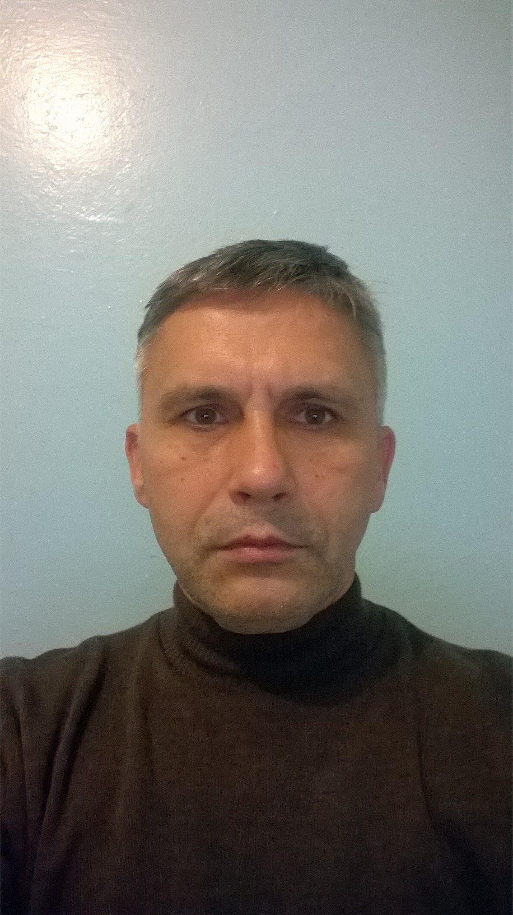
▪ Support, software upgrade opera day, treasury, currency posting, cash transactions, loans
▪ Consultation and training of employees
▪ Support functionality of servers and workstations
▪ Closure of the day, voucher
▪ Development of auxiliary programs foxprox 2.6

1999-2001 Tax Inspectorate
Chief Specialist

▪ Update, support over 30 workstations
▪ E-mail
▪ LAN support
▪ Routing
▪ Protection, security

2001 Kiev Institute of retraining of tax inspectorate executives Kyiv
Chief specialist of the department of informatization

▪ Installation, updating of the Accounting Software
▪ Written and installed software, testing knowledge of PE managers
▪ Support 60 workstations

2002-2007 Employment Center
The main specialist

▪ Service Informox database server, installing programs, setting up, backup backup
▪ Install the new program EAS for service unemployment population
▪ Install miniATC
▪ BuhAccounting Software Installed
▪ Serving 2 servers and 10 workstations
▪ Creating backups of the database inform
▪ Daily date synchronization
▪ LAN and WAN support
▪ Reception and interviews with the unemployed (department of social services provision)
▪ Performing the functions of the controller

2007-2011 Tax Inspectorate
Chief Specialist

▪ Update, support for more than 30 workstations
▪ Diagnostics, repair of the PC
▪ (WEB-server (local Apache + PHP + oracle + corba), liga 8.15, Liga7, ftp, frames, salary, dilkon-clerk, Best report, state register ....)
▪ E-mail FossMail
▪ MS Office xx
▪ DR web enterprice Server 5 installation, setting, upgrade
▪ Installation, configuration, functionality support, backup of Oracle 9.2.0.8, recovery (Cold, logging).
▪ Intellect-Service Accounting Software
▪ Serving 5 windows2003 server servers and 24 workstations windowsxp prof (installation and configuration)
▪ Development of auxiliary programs
▪ Support for LAN functionality and Internet network
▪ Routing, NATActive Directory, such as backup, Security, DNS, DHCP, RIS, RRAS, DFS,

2012….
Freelance
▪ Rework functionality , makeup:
- CMS Open cart 1.5,
- Wordpress- Widget, layouts, custom fields….
- Laravel, Yii2 - changing makeup(base level)
2018
Ambulance
▪ Update, support over 30 workstations
▪ E-mail
▪ LAN support
▪ Routing
▪ Protection, security

WMI
▪Education 1989-1994 Cherkasy State Pedagogical Institute of Cherkasy
▪ Faculty: Physics and Mathematics
▪ Specialty: physics-mathematics
▪ Certificates: SoftLine Kyiv

Experience

▪ WEB: HTML, CSS, Bootstrap, JS, PhotoSHop, JAVA (base level), AJAX, Angular (base level), OOP, PHP 5, OpenCart (1.5, 2.0), Wordpress
▪ Operating systems: Windows 2000 server, Windows 2003 server, windowsXX, Ubuntu 16.4
▪ OpenServer, EasyPhp
▪ YII2(base), Laravel(base), Angular 2(base),React(base), JQUERY
▪ HTML, CSS, JavaScript(native), Booustrap 3(grid)

Language: English (technical, preintermediate spoken), Ukrainian, Russian

Date of birth 1969

